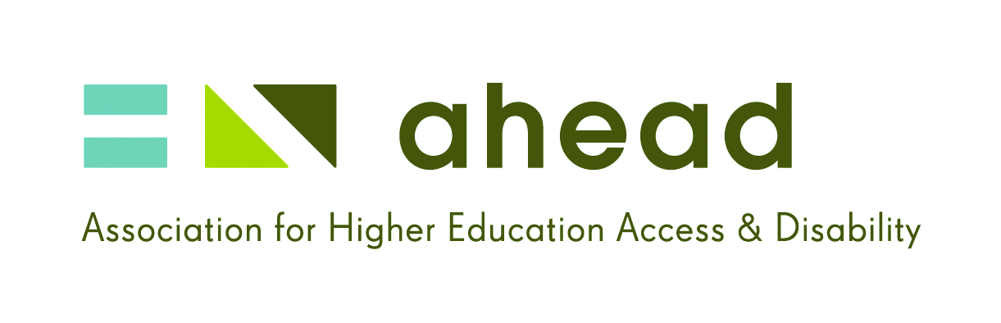

Members Newsletter

Issue 5, April 2012

Pictured below: Delegates at the AHEAD Conference 2012

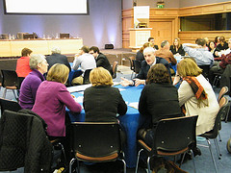

It’s time for a change.

By Ann Heelan, Director
At the recent AHEAD conference we heard from absolutely amazing teachers with disabilities. Sean Herlihy who works in St Joseph’s School for Deaf Boys showed us how he moves between two distinct languages in the classroom - English and Irish Sign Language. His deep understanding of the learning needs of his deaf students and his ability to connect with his pupils were obvious, as were the difficulties a non ISL speaker would have in trying to communicate to Deaf children.
We also heard from Sinead Burke, a trainee teacher in Marino Institute who is teaching a class of boys in an inner city school. She enthralled the audience with her experience of dealing with name calling in the classroom and her skill in turning a potential bullying situation into a learning exercise on the power and dangers of labelling. Perhaps the most interesting outcome is that the children don’t see disability as a negative thing, they see a teacher who is interesting and fair and they simply accept it.
Without a doubt, people with disabilities are an untapped asset to teacher education. They are different, they learn differently and communicate differently and this difference brings creativity to the learning experience of all children. After all, many children have difficulties with learning that will be helped by a more child centred approach and a variety of teaching tools such as multi media and computers.
So what are the barriers to teacher education for people with disabilities and how can we break this cycle of exclusion? According to Dr. Anne Lodge from the Church of Ireland College of Education the culture needs to change. Teacher education has a tacit culture of care and a status quo that is very paternalistic. Unfortunately this leads to over protectiveness and a lack of willingness to change the rules. After all if we see people as needing care we are unlikely to give them responsibility. Other issues were raised on the day in relation to the inflexibility of the entry policy to teacher education, in particular with regard to Irish as an entry requirement irrespective of whether it is the language of the classroom.
The unacceptable truth remains that students with disabilities are under -represented in teaching. The current policy on entry to teacher education no longer serves the needs of children with disabilities in the education system. We all know that education needs to change to meet the learning needs of all the children in the classroom with an eye to the future, but the question is how far are we prepared to go?

Are all supports created equal?

By John Paul Byrne
Reasonable accommodation is the term used to denote any support, adjustment or action required for an individual in order to minimise any disadvantage associated with an impairment or condition and ensure equality of access and opportunity. Irish equality legislation places a legal obligation on employers to reasonably accommodate people with disabilities, in order to ensure equality of opportunity in the recruitment, selection and employment of all job applicants and staff members.
While the legislation does provide some examples of ‘appropriate measures’ that employers may have to take, and there are publicly funded grants available to private sector employers in order to assist with the provision of supports for staff with disabilities, these approaches tend to have a limited focus on the range of potential support requirements i.e. assistive technology, alternative equipment, the use of sign language interpreters for interview or retraining of staff who have acquired a disability.
Due to the indistinct nature of employment equality legislation, the limited range of employer grants and general stereotypical perceptions around disability, there can be ambiguity for employers in identifying what exactly a reasonable accommodation can be. The danger here is the potential neglect of the variety and flexibility of supports required in favour of a focus confined to the more prominent, costly supports.
The AHEAD WAM Programme’s experience in facilitating and supporting mainstream work placements for graduates with disabilities has highlighted the fact that many support requirements in the workplace are not based on interpreters, equipment or technology. In fact, the majority of reasonable accommodation requirements for WAM placements have related to methods of information provision i.e. alternative training methods, adjusted learning techniques and adapted communication/meeting methods. For those with mental health issues, allocated time off for scheduled medical appointments has also proven to be a significant advantage in undertaking full-time, mainstream work.
Most employers have no problem in identifying physical access, assistive technology or the use of sign language interpreters as reasonable accommodations. However time off for medical appointments or alternative training, meeting or communication techniques are often not considered with the same weight. This could be a consequence of being viewed as a less obvious or less urgent support need, but in the long term, they are no less important.
Underlying state and employer policies which seek to support the diverse needs of people with various disabilities must be an approach which also ensures equity of reasonable accommodation. Ignoring this issue could lead to a situation where the mainstream labour market is only open to people with certain disabilities - in effect, providing necessary supports for some and creating further barriers for others.
The range of different disabilities and unique people is immeasurable. Attempting to support the potential requirements of such diversity requires an equally varied and flexible approach to the provision of reasonable accommodations - one which includes, but looks beyond, the provision of technology, interpreters and equipment, to smaller scale, possibly more time-intensive, but equally important, supports and adjustments. Sometimes it is the small details that have the biggest effect.
A WAM Participant with Dyslexia on using Reasonable Accommodations:
‘I’ve learned an awful lot in terms of using the different coloured screen [and] reading off different coloured paper has made an awful lot of difference. I can do an awful lot more and I am nowhere near as tired as I would have been... Using the different font and colour has made a difference... I definitely figured out that I can do this and I am good at this! ’

Assistive Technology in Microsoft Word

By Dara Ryder
As technology evolves at an ever faster pace, assistive software and hardware is playing a bigger and bigger role in the lives of people with disabilities. New and improved screen readers, magnifiers and spelling and grammar checkers are released every year, bringing people who would otherwise be unable into the realm of the internet and beyond and enriching the electronic experience of others.
While much of this software is on the margins and aimed specifically at people with disabilities, it is notable that the big IT companies have been taking more and more care to make their products more accessible and most have included very basic versions of the types of AT mentioned above into their own operating systems and programs.
It may come as a surprise to some people to know that Windows XP, currently the most commonly used operating system in the world, has many accessibility features built in to its feature set, including basic versions of all of the above.
For visually impaired users, the Magnifier enlarges the area around the cursor in a separate window at the top of the screen (see picture below), the Narrator provides a very basic screen reader and the high contrast function gives better clarity (useful for some dyslexic users too). The On-Screen Keyboard and Sticky/Filter/Toggle Keys settings enable users with limited movement in their hands to use the keyboard and type with minimal errors. For hearing impaired users, Sound Sentry flashes visual alternatives to replace the operating system’s audio warning signals.
It should be said at this point that none of these limited features should ever be used as a replacement for commercial software aimed at people with disabilities, as they currently have nothing like the functionality and range of features which come as standard with the best commercial assistive software. Rather they can be used as a capable stop-gap or for example if a person with a disability is temporarily using a computer which is not theirs.
The good news is that these in-built tools have improved slightly with every version of Windows and will keep improving so it is realistic to hope that one day in the not too distant future, that disabled users will not have to fork out for expensive commercial tools, which admittedly make their lives richer, but unfortunately make their wallets poorer.
For more information on accessibility in XP and where to find the tools listed in this article please go to http://bit.ly/HOlfYZ.

A foot in the door

By Fionnuala Fay
I started in Abbott in July 2010 just a month after finishing my final year in college. I had been applying for any and all graduate positions during my final year and the disability service in college sent me on the WAM job application. Abbott was one of the companies which were taking on engineering graduates. Abbott specifically appealed to me because my degree is in biomedical engineering and Abbott is one of the leading companies in the stent business in one of the specific fields I wanted to get into.
I was lucky enough to be offered the placement around May of my final year before I even sat my final exams. Knowing that I had a job lined up after college was a huge relief and took so much stress away.
I was placed in the training department. I didn’t really know what to expect, but we had an induction day with the WAM personnel on the first day. We went through what to expect from the programme, how Abbott worked and how the placement should go.
WAM had also set up a mentoring programme with Abbott personnel, in which each graduate was assigned a mentor who we could meet throughout the placement to discuss any issues or problems we were having. I thought this part of the programme was brilliant; my mentor was so helpful throughout the placement. We’d just meet up for a coffee and a chat and it really helped me to settle in.
The group I was placed into was brilliant; I was given projects and goals to achieve by the end of the placement. My supervisor ensured I was given any support I needed but mainly I was given the freedom and responsibility to perform my job without any prejudice.
Luckily while on placement I was able to apply internally for other graduate positions within Abbott. I was open during the interviews about starting in Abbott via the WAM Programme and the manager and supervisor completely understood and again ensured if I needed any support to let them know. I am still currently working in Abbott at the moment and was just recently made permanent.
The WAM Programme gave me the foot in the door to start my career which is so difficult for gradates to get. I am so grateful for all the help and support I was given from WAM and from Abbott. I was so grateful to the WAM Programme that I signed up to be a mentor to new WAM graduates coming in.
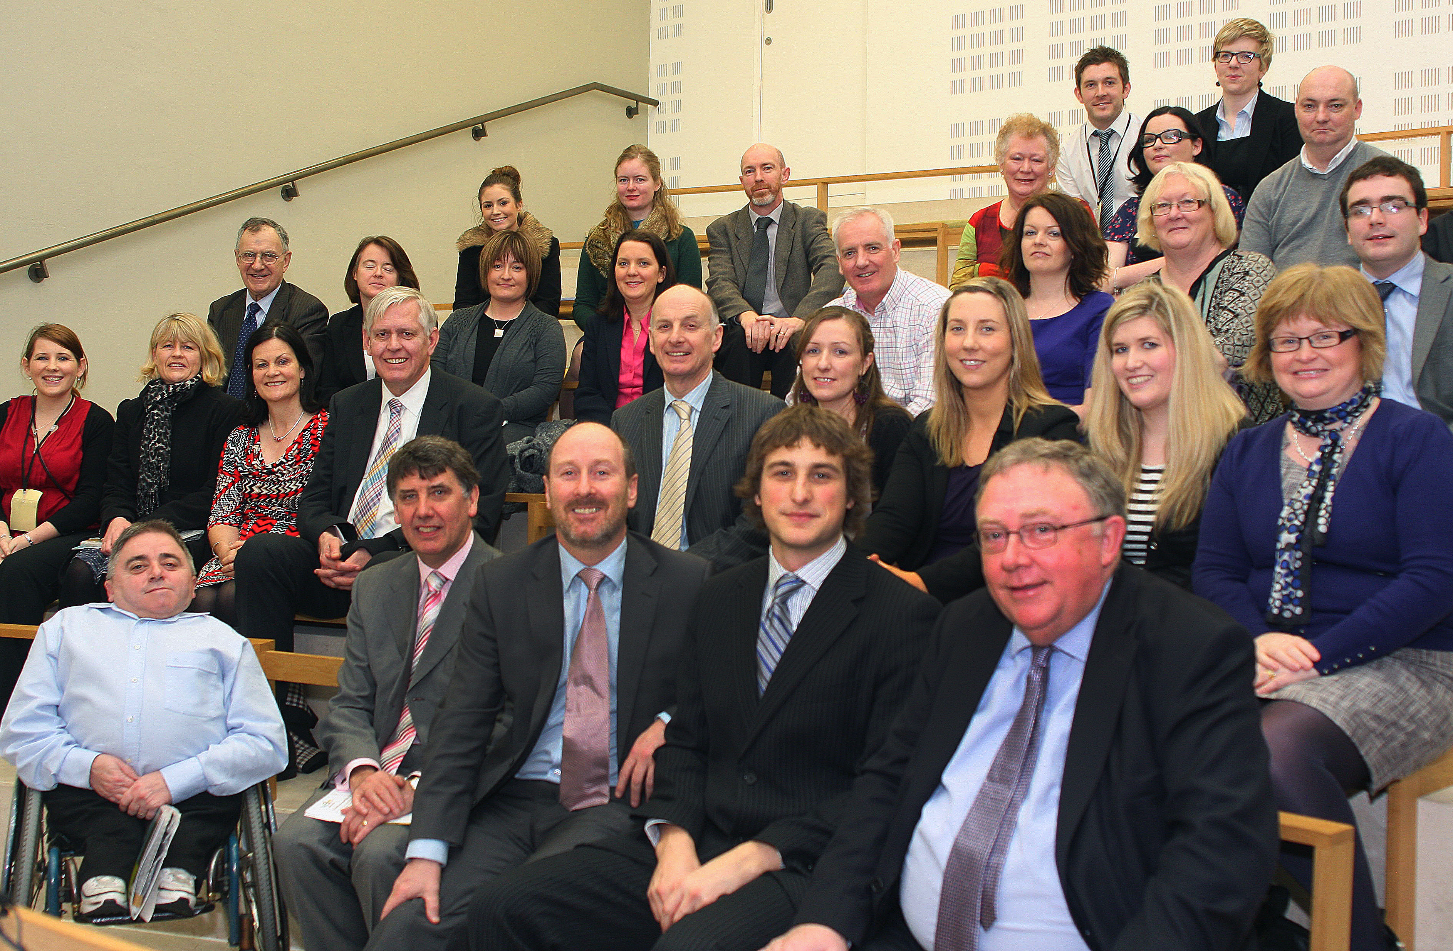
The AHEAD WAM Leaders Event in the Houses of the Oireachtas on 22nd Feb

Conference Call for Papers

We can’t go back, not now! (Tintin)

Transition from higher education to work: the role of students with a disability, higher education, employers and professional bodies.
The LINK Conference 2012 will take place on October 4th 2012 in Ghent, Belgium. The conference will address the topic of transition from higher education to work for students with disabilities and in particular will analyse the individual roles of students themselves, the higher education institutions and the employers.
Are you an academic, employer, policy maker or student with a disability and do you have a concern or some strong opinions about work and transition to work? We would like you to share your experiences. If you are interested in submitting a paper for presentation at the conference please download the full call for papers at bit.ly/HcCSak and follow the instructions.
All proposals need to be submitted by email to contact@linknetwork.eu on a proposal submission form which can be downloaded at bit.ly/HhdRIG by April 15th 2012.
Booking for the event will commence later in the year and we will be in touch to notify interested parties.
Don’t forget to spread the word and get your colleagues to become a LINK member free of charge by visiting www.thelinknetwork.eu.

News in Review

The top ten stories from our Weekly News In Review Service:
- Attitudes towards disabled more negative in past five years – report | http://bit.ly/xMQyZc
- Column: I’m jobless, so why am I excluded from JobBridge? | http://bit.ly/xJAmlM
- I haven't a clue if lecturers are doing their jobs, says minister | http://bit.ly/zYlqmi Epilepsy still has strong social stigma for sufferers | http://bit.ly/Apr6Ei
- New kind of technology university will address the needs of society | http://bit.ly/A4FcSt
- How Chuck's cash changed Irish research | http://bit.ly/yCFk7B
- How qualified is your lecturer? | http://bit.ly/yCTLHU
- Disabled people's magazine taps a 'niche for positivity' | http://bit.ly/A8A9fb
- Teachers must come from all sections of society | http://bit.ly/GBGFh0
- School stalemate over assistance dog in classroom | http://bit.ly/GQ5dzB

Upcoming Event
Students & Graduates with Disabilities looking for work should mark Tuesday 29th May 2012 in the diary for the next Get AHEAD Building the Future Event. More information will be on www.ahead.ie shortly.

Get Connected!
- Find us on Facebook: www.facebook.com/ahead.ie

Follow us on Twitter: @get_ahead

Contact Us
East Hall, UCD, Carysfort Avenue, Blackrock, Co. Dublin
Phone: 01 716 4396 | Web: www.ahead.ie | Email: ahead@ahead.ie

